Who Is Your Personal Savior and Mediator?
I feel the need to start by saying that I have discovered that members of the LDS Church are divided on the following topic. I have discussed these screenshots with an LDS friend and he disagree with my interpretation. Then I posted the same screenshots on an LDS Facebook group page and the majority of people online agreed with my interpretation, while others were surprised to read what appear to be clear statements. So it will be up to you to decide for yourself how you believe the following screenshots should be honestly interpreted:
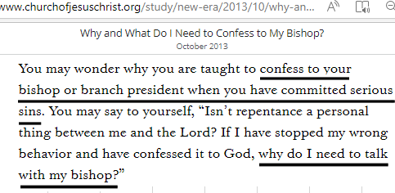

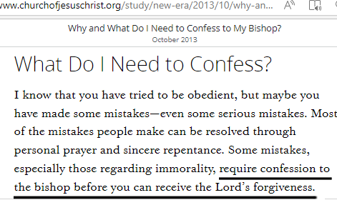
___________________________________________________________________________________________________
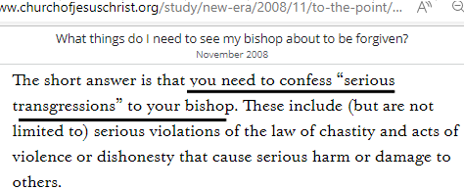
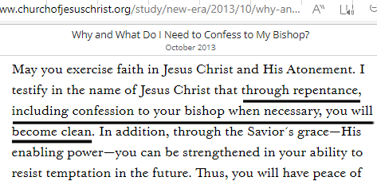
______________________________________________________________________________________________________
According to the official churchofjesuschrist.org website, I believe that it is abundantly clear that LDS Church doctrine states that if you commit a serious sin (breaking the law of chastity), that you are then required to confess that sin to your bishop. And only after doing so will God forgive your sins.
Imagine that a faithful member of the LDS Church committed a serious sin and felt great sorrow for disobeying God. This person confesses their sin to God. They also confess to their close friends and ask for prayer, support and accountability. The articles above are clear that even though this person is sincerely repentant of their sin, they would still not be forgiven because they have not confessed their sin to their bishop.
______________________________________________________________________________________________________
A mediator is someone who is “in between” you and God. He is the one who can reconcile your relationship with God and declare that you are clean and forgiven. We have all broken God’s law (Romans 3:23; James 2:10). According to God’s Word, who must we confess all of our sins to as our personal mediator in order to become forgiven of our sins?
1 Timothy 2:5 “For there is one God, and ONE MEDIATOR between God and men, the man Christ Jesus.”
1 John 1:9 “If we confess our sins, he is faithful and just to forgive us our sins and to cleanse us from all unrighteousness.
According to God’s Word, who do we need to confess our sins to? The one who is faithful and just to forgive us. Jesus alone is the only mediator between man and God the Father. A personal/direct mediator is someone who you can directly approach. By confessing our serious sins directly to God and God alone, we can find forgiveness. If I am required to confess my serious sins to my bishop, who has then become my personal/direct mediator?
James 5:16 “Therefore confess your sins to each other and pray for each other so that you may be healed. The prayer of a righteous person is powerful and effective.”
We read here that it is good to confess our sins to one another. The purpose is for accountability, prayer, and support. Is it good to confess our sins to one another to help us overcome them? Absolutely! Are we required to confess our sins to a specific individual on earth before we can receive God’s forgiveness? Absolutely not!
_____________________________________________________________________________________________
“In July 2023, I invited some missionaries to my work office. I bought them lunch and we had a great discussion on this topic. Towards the end of our conversation, I said to them, “I strive to die to myself and live for Christ every day. I pray for him to help me to resist sinful temptations. I have confessed all of my sins (big and small) directly to Jesus. I am sincerely trying to love God by obeying His commands. God has captured my heart. But I have never confessed my sins to a bishop. Have I been forgiven of my sins?” The missionary politely responded by saying, “It’s not my place to judge but it’s possible that you might not have been forgiven.”
_____________________________________________________________________________________________
Let us remember what Scripture has stated: that we can go directly to God alone as our mediator, confess all of our sins directly to Him and he will personally forgive us of all our sins and unrighteousness. There is no one else that we are required to confess to in order to receive forgiveness of sins.
This privilege of being able to have that direct access to Jesus by going directly to Him in prayer as our personal mediator and laying down all of your sins (regardless of how serious they are) at the foot of the cross is what it means to have a personal relationship with Him.
_____________________________________________________________________________________________

In general, the more we talk with someone, the stronger that relationship becomes. Prayer is how we talk to God. The more we talk with God, the stronger that relationship becomes.
John 14:14 “You may ask me for anything in my name, and I will do it.”
We also see an example of Stephen the martyred apostle pray to Jesus in Acts 7:59
“While they were stoning him, Stephen prayed, “Lord Jesus, receive my spirit.”
This faithful apostle who gave up his life for the gospel clearly prayed to Jesus. And Jesus himself said that we can pray to him and ask him for anything. Why then does the LDS Church teach that we can’t pray to Jesus? Can you honestly call Jesus your “best friend” and “personal” savior when you are not even allowed to pray/talk to him?
Growing up, Michael Jordan was my favorite basketball player. I remember having a Michael Jordan basketball card collection with over 50 different cards. I looked at his statistics and read books about him as well. Today, I feel like I know a LOT about Michael Jordan…but it would be delusional for me to ever say that I have a personal relationship with Michael Jordan. In the same way, just because I might know and read a lot about Jesus from the Scriptures, that doesn’t automatically mean that I have a personal relationship with Jesus. If I am never praying/talking to Jesus, then it would also be a mistake to believe that I have a strong, personal relationship with him as well.
Believe it or not, focusing on a personal relationship with Jesus has been strongly discouraged by the LDS Church when apostle Bruce McConkie said, “It is no secret that many false and vain and foolish things are being taught in the sectarian world even among us about our need to gain a special relationship with the Lord Jesus. . . . In an attempt to be truer than true [Christians] devote themselves to gaining a special, personal relationship with Christ that is both improper and perilous. . . . Another peril is that those involved begin to pray directly to Christ because of some special friendship they feel has been developed. In this connection a current and unwise book, which advocates gaining a special relationship with Jesus, contains this sentence—“Because the Savior is our mediator, our prayers go through Christ to the Father, and the Father answers our prayers through His Son.” This is plain sectarian nonsense. Our prayers are addressed to the Father and the Father only. They do not go through Christ. (Bruce R. McConkie - Quorum of the 12, Church News, 3/20/82)

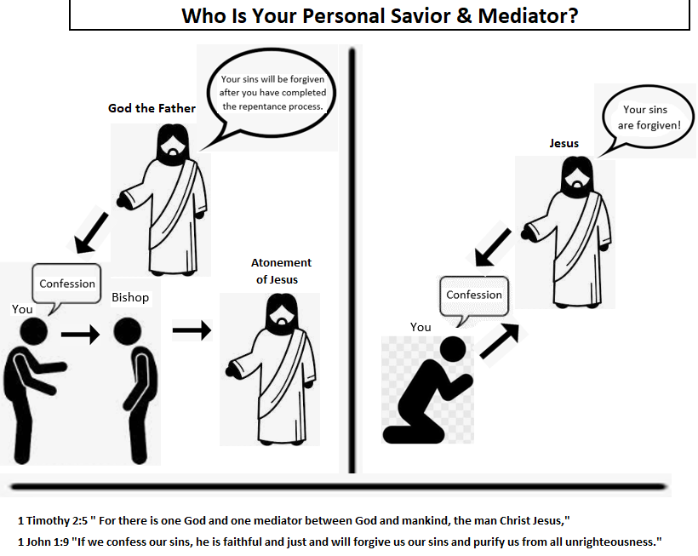
The primary concern is that in general, Latter Day Saints are missing out on this personal and intimate relationship with Jesus. My sincere hope is that one day you will have a relationship with Jesus (right side of the picture above) where you can pray directly to him and lay all of your sins at the foot of the cross with no one else being involved for the forgiveness of your sins, regardless of how serious they are. This is what it means to have a personal relationship with Jesus as your personal mediator and direct Savior. I invite you to ponder and pray about these things, and most importantly to look to the teachings of Jesus and his apostles for guidance.

